BANK LOAN REPORT

KPI’s

1. Total Loan Application.

select count(id) as Total_Loan_Applications from Bank_Loan_Data

1. Month to Date – Total Applications in December month.

select count(id) as MTD_Total_Loan_Applications from Bank_Loan_Data

WHERE MONTH(issue_date) = 12 AND YEAR(issue_date) = 2021

1. Total Loan Issued.

select sum(loan_amount) as Total_Funded_Amount from Bank_Loan_Data

1. Total funds released in a month

select sum(loan_amount) as Total_Fund_Month from Bank_Loan_Data

WHERE MONTH(issue_date) =12 AND YEAR(issue_date) = 2021

1. Total Amount bank received from bank loan data.

select sum(total_payment) as Total_Amount_Bank_Received from Bank_Loan_Data

1. Total amount received in a month

select sum(total_payment) as Total_Amount_Bank_Received_in_month from Bank_Loan_Data

Where Month(issue_date) =12 AND Year(issue_date) = 2021

1. Average Interest rate

select avg(int_rate) * 100 as Average_Interest_rate from Bank_Loan_Data

1. Rounding the Percentage to 2 decimal places

select Round(avg(int_rate),4) * 100 as Average_Interest_rate from Bank_Loan_Data

1. Good Loan Percentage

Select

(count (case when loan_status = 'Fully Paid' or loan_status = 'Current' then id END)*100)

/

count(id) as Good_Loan_Percentage

from Bank_loan_data

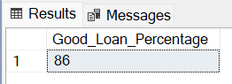

1. Good Loan Application

Select count(id) as Good_Loan_Applications from Bank_Loan_Data

Where loan_status ='Fully Paid' or loan_status = 'Current'

1. Good Loan Funded Amount

select sum(loan_amount) as Good_Loan_Funded_Amount from Bank_Loan_Data

where loan_status ='Fully Paid' or loan_status = 'Current'

1. Total amount bank received

select sum(total_payment) as Good_Loan_Received from Bank_Loan_Data

where loan_status ='Fully Paid' or loan_status = 'Current'

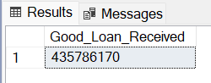

BAD LOAN ISSUED

1. Bad Loan Percentage  
   Select

round((count (case when loan_status = 'Charged off' then id END)*100.0)

/

count(id),2) as Bad_Loan_Percentage

from Bank_loan_data

1. Total # of Bad Loan Applications.

Select count(id) as Bad_Loan_Applications from Bank_Loan_Data

Where loan_status ='Charged Off'

1. Bad Loan Funded Amount

Select sum(Loan_amount) as Bad_Loan_Funded_Amount from Bank_Loan_Data

Where loan_status ='Charged Off'

1. Bad Loan Amount Received

Select sum(total_payment) as Bad_Amount_Received from Bank_Loan_Data

Where loan_status ='Charged Off'

**LOAN STATUS**

1. Loan status of all application

Select

loan_status,

count(id) as Total_Loan_Applications,

sum(total_payment) as Total_Amount_Received,

sum(loan_amount) as Total_Funded_Amount,

Avg(int_rate*100) as DTI

from

Bank_Loan_Data

group by

loan_status

1. Month to date amount received and funded.

Select

loan_status,

sum(total_payment) as MTD_Total_Amount_Received,

sum(loan_amount) as MTD_Total_Funded_Amount

from Bank_Loan_Data

where month(issue_date) =12

group by loan_status

II Dashboard

1. What are total amount received, funded and # of application each month

select

MONTH(issue_date)as Month_Number,

Datename(month, issue_date)as Month_Name,

count(id) as Total_Loan_Applications,

sum(loan_Amount) As Total_funded_amount,

sum(total_payment) as Total_Received_Amount

from bank_loan_data

group by MONTH(issue_date), Datename(month, issue_date)

order by MONTH(issue_date),Datename(month, issue_date)

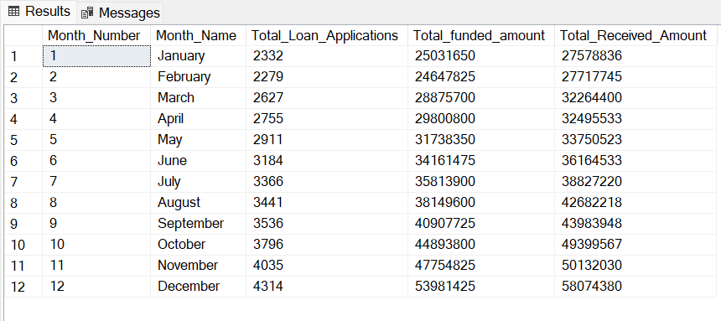

1. Loan status as per state.

select

address_state,

count(id) as Total_Loan_Applications,

sum(loan_Amount) As Total_funded_amount,

sum(total_payment) as Total_Received_Amount

from bank_loan_data

group by address_state

order by address_state

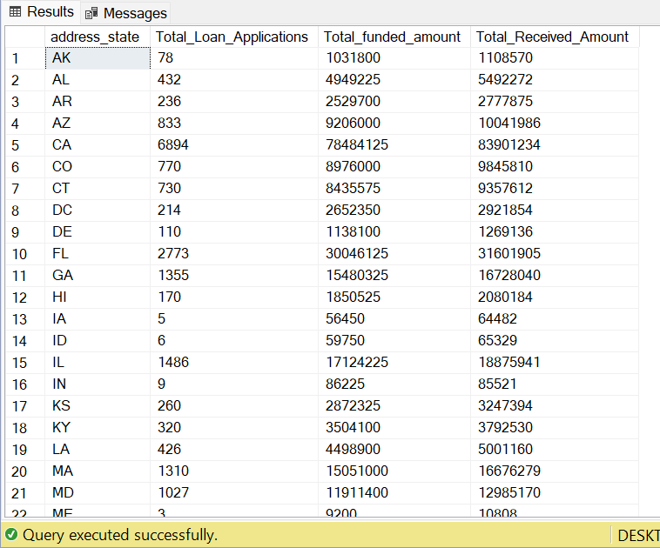

1. Loan status as per Term

select

term,

count(id) as Total_Loan_Applications,

sum(loan_Amount) As Total_funded_amount,

sum(total_payment) as Total_Received_Amount

from bank_loan_data

group by term

order by term

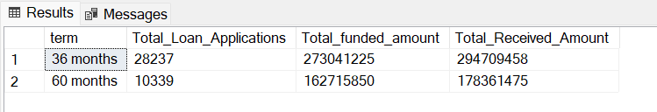

1. Loan status as per emp length

select

emp_length,

count(id) as Total_Loan_Applications,

sum(loan_Amount) As Total_funded_amount,

sum(total_payment) as Total_Received_Amount

from bank_loan_data

group by emp_length

order by emp_length

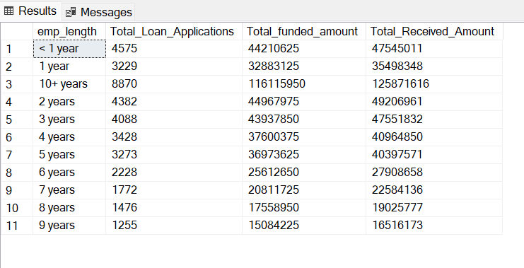

1. What purpose people are getting loans.

select

purpose,

count(id) as Total_Loan_Applications,

sum(loan_Amount) As Total_funded_amount,

sum(total_payment) as Total_Received_Amount

from bank_loan_data

group by purpose

order by count(id) desc

1. Loan_status based on home ownership

select

home_ownership,

count(id) as Total_Loan_Applications,

sum(loan_Amount) As Total_funded_amount,

sum(total_payment) as Total_Received_Amount

from bank_loan_data

group by home_ownership

order by count(id) desc

